CCMI Marine Ecology Course Scholarship Application 2022

Apply for your class to receive a full scholarship to attend CCMI’s Marine Ecology Course (MEC) at the Little Cayman Research Centre.

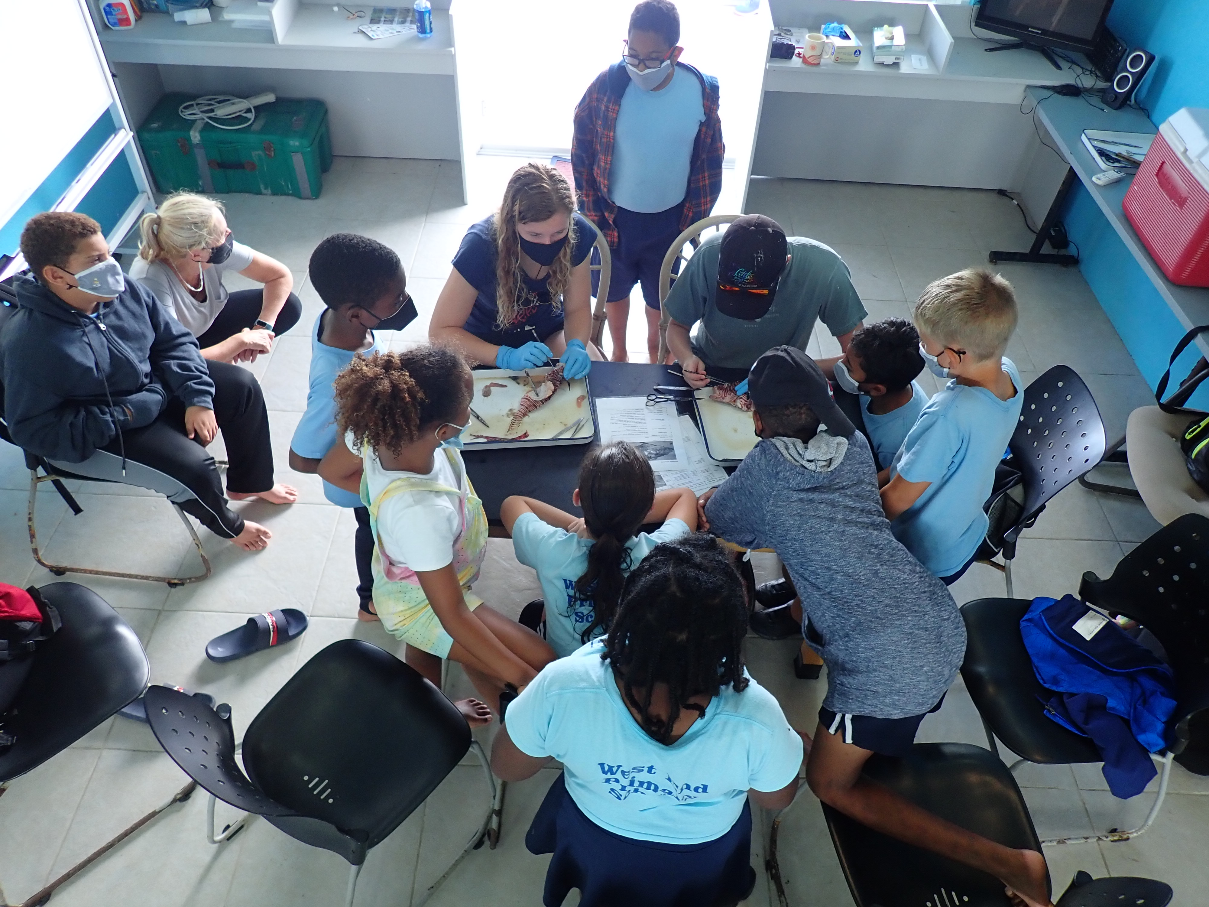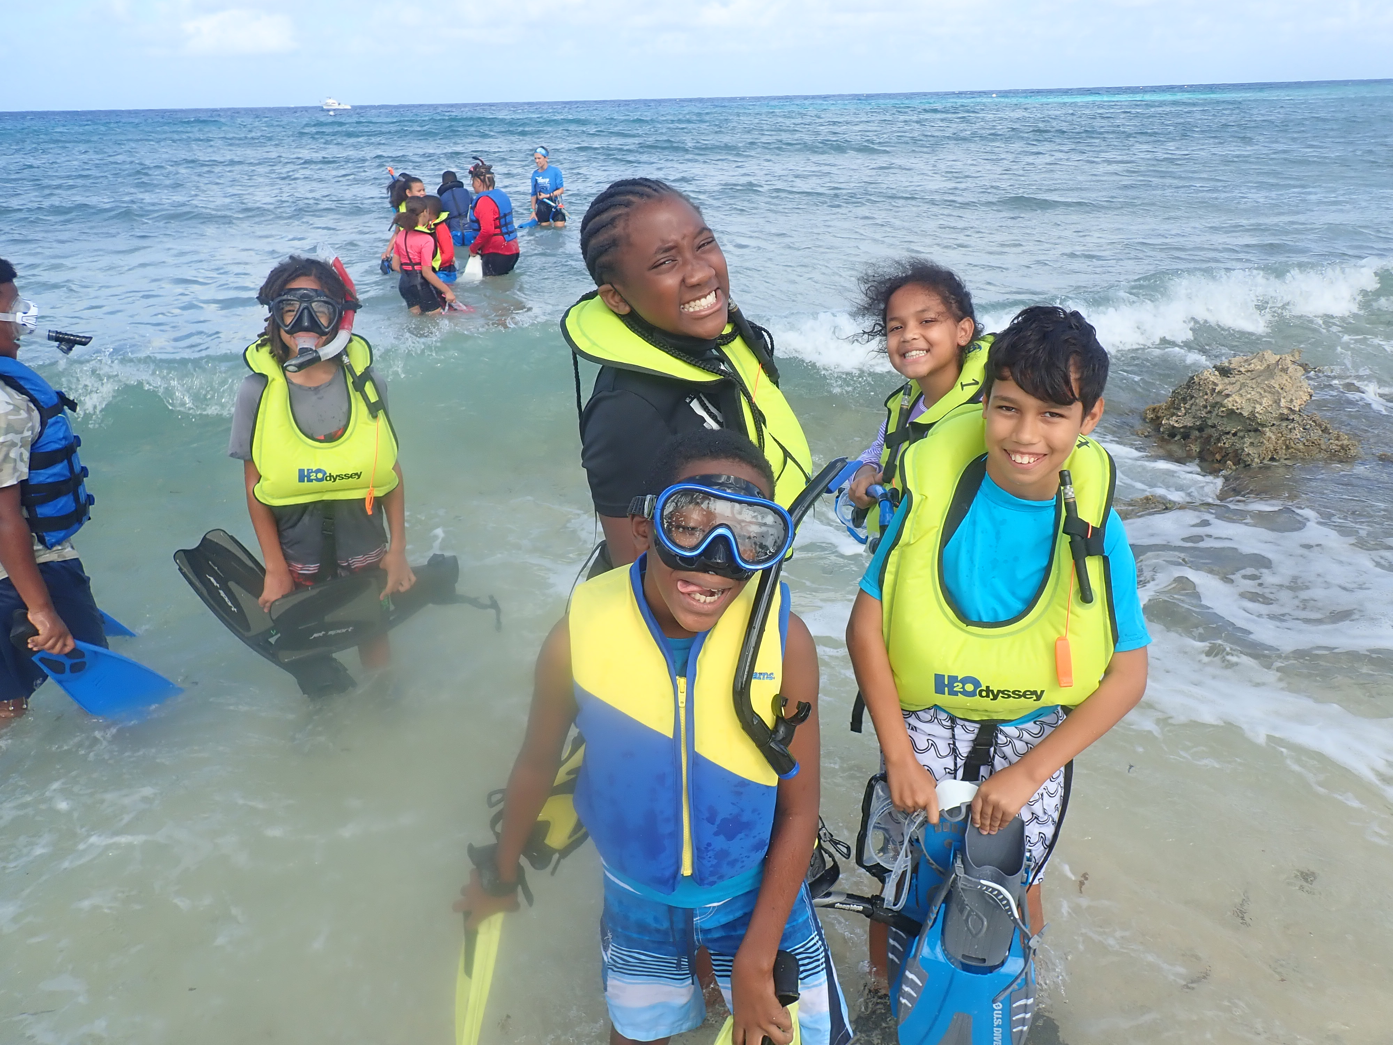

What is the Marine Ecology Course at CCMI?
Since 2009, more than 900 primary school students across the Cayman Islands have participated in this immersive three-day, two-night field trip to Little Cayman. Course participants get a chance to live at the Little Cayman Research Centre and learn more about the oceans first-hand! During their stay, students enjoy a range of activities, including snorkeling, marine species identification, beach cleanups, cultural field trips, a guided iguana tour, biking, and much more!

Thanks to the BODA Trust, two classes from government primary schools will be selected to receive this experience at no cost to them. To determine which classes are selected, CCMI is requesting applications for the available scholarships, inviting classes or environmental/science clubs from years 5 and 6 at the Cayman Islands government primary schools to participate.

Programme Dates for the winning classes: December 6th-8th and December 12th–14th, 2022.

How to enter?
Educators who wish to have their classes considered for a class scholarship to attend the all-expense paid, three-day long MEC should submit the following:
- Application form (next page) including a paragraph explaining why their class should be selected for this experience. This may include what it would mean to the students, how the experience will benefit the class, what students will gain from participating in the course, and why students are interested in learning about the oceans/coral reefs with CCMI.
- A creative way of showing CCMI and the BODA Trust how badly they want this opportunity. Educators can submit, from the students a writing piece, an art piece, a song, or even a quick video as a class saying why they want to come to CCMI! This is your student's chance to demonstrate why their class deserves to be selected for this scholarship. You can be as creative as you wish and even have your entry link to your lessons in the classroom.

*Please note all submitted entries and their content may be published and shared publicly on platforms to include, but are not limited to, CCMI’s social media accounts, CCMI’s website, and press releases to local media outlets.

How to submit and when?
The deadline for submissions is Wednesday, 23rd June 2022. Submissions need to be sent to education@reefresearch.org. CCMI judges will announce the winners on Monday, 27th June 2022 before the term ends.

*Each awarded class must provide 1 male and 1 female chaperone to accompany students and assist with classroom management for the programme in Little Cayman.
Application

Name of school: Click or tap here to enter text.

Grade/Year: Click or tap here to enter text.

Number of students in class/club: Click or tap here to enter text.

Approximate breakdown (for accommodation purposes): Boys Click or tap here to enter text. Girls Click or tap here to enter text.

Teacher’s name: Click or tap here to enter text.

Teacher’s email address: Click or tap here to enter text.

Please submit your paragraph below (use additional space if necessary): Click or tap here to enter text.

